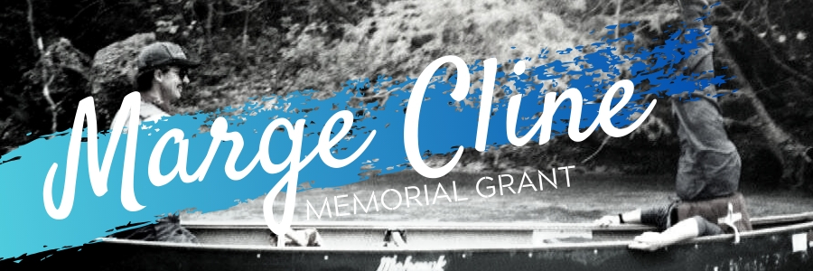
Grant Overview: Each year, as funding permits, the ACA will grant up to $1,000.00 to individuals or non-profit organizations to provide paddlesports opportunities for youth in the Midwest. These funds must be used to further an individuals’ ability to participate in canoe, kayak, SUP, or rafting. A condition of acceptance is that the recipient(s) will commit to giving back to their local paddling community.
Eligibility Criteria: In order to be considered for this grant program, the applicant must meet the following criteria:
Individual
- 20 years old or younger
- Live in one of the following Midwest states:
  - Illinois
  - Indiana
  - Michigan
  - Wisconsin

Organization
- Non-profit organization or paddling club
- Membership / area of focus primarily based in the Midwest

Additional Criteria
- An individual/organization cannot receive the grant two years in a row
- If selected, the recipient agrees to give back to their paddling community as outlined in their application

Conditions of Acceptance
- Within 30 days of completing the grant project, the recipient(s) will submit a final report to the ACA, including:
  - Written summary of activities
  - Explanation for expenses/itemized expense list with receipts
  - High resolution pictures and/or videos from grant funded activities

Marge "River Mom" Cline Memorial Grant Application
Email this document to the ACA Membership Department at mailto:aca@americancanoe.org
Your Name:
Your Complete Mailing Address:
Your Email Address:
Your Phone Number:
For Individuals:

How will the grant funds help you achieve your paddlesports related goal(s)?

Community Service: what will you do to give back to your local paddling community?

For Non-Profit Organizations:

How will this grant funding encourage or increase your ability to offer youth paddlesports opportunities?

Community Service: what will your organization do to give back to your local paddling community?
Biography:

For individuals, please include a personal biography which includes your interest and participation in paddlesports.

For Non-Profit Organizations, please include a description of your organization and the community, paddlesport, and youth activities in which you work. Please also include your organization logo and website URL.
Budget:

Amount of money requested (up to $1,000.00)

Outline how funds will be spent.
*Please attach additional pages if needed.

