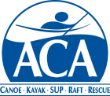

Competition Council Conference Call
Agenda

- Roll Call
- Welcome – 5 min
- Introductions – 5 min
- Competition Council overview – 15 min
  - Your role on the Competition Council
- Elections discussion – 5 min
- Competition Council Meeting/Leadership Academy – 10 min
- Open Discussion – 10 min
- Closing – 5 min

